
How To Play

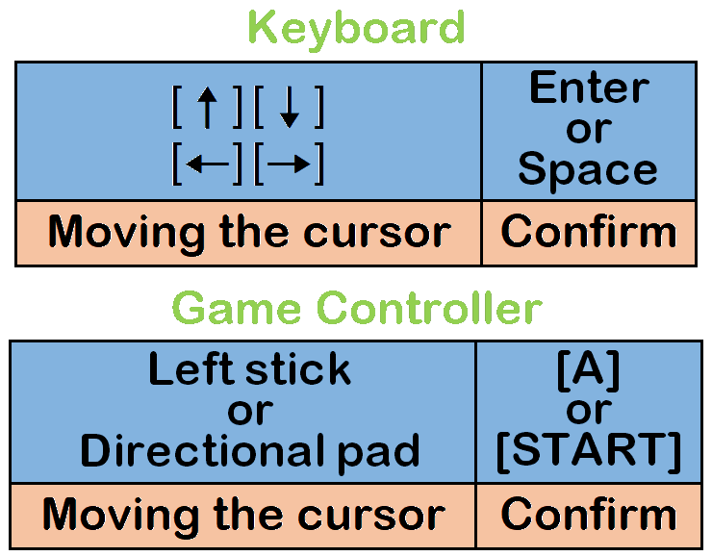
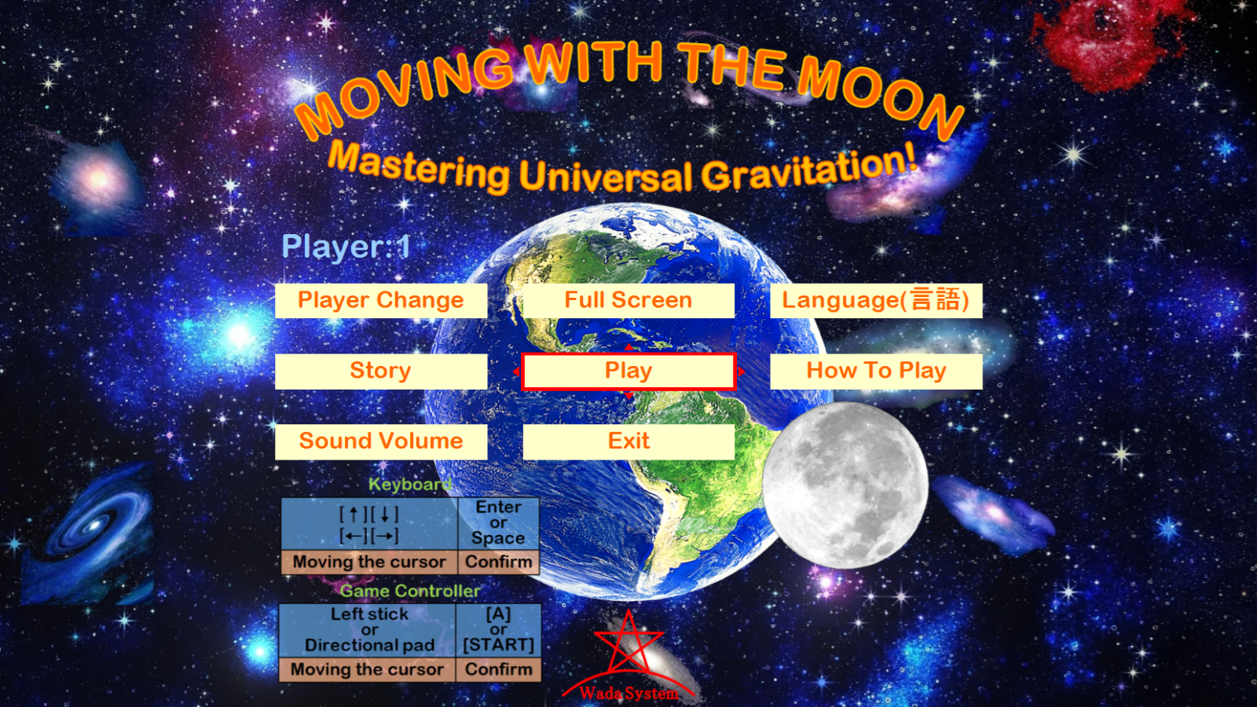
How To Operate The Menu Screen, Etc.

(Buttons on the menu screen, etc. can also be pressed with the left mouse button.)

Game Screen Explanation
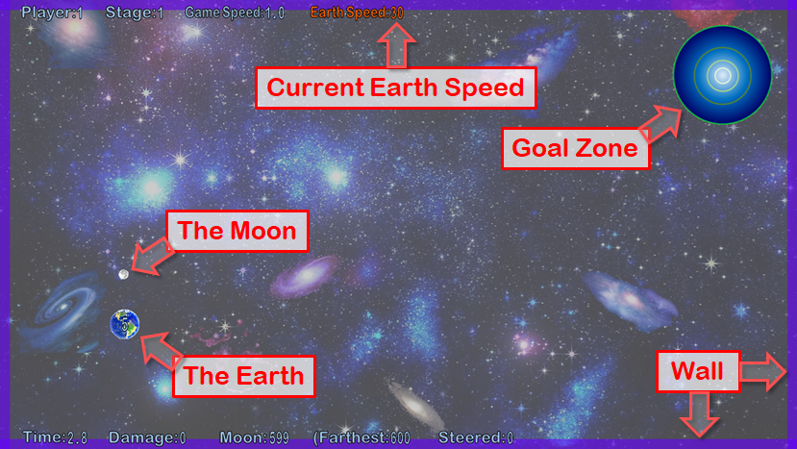
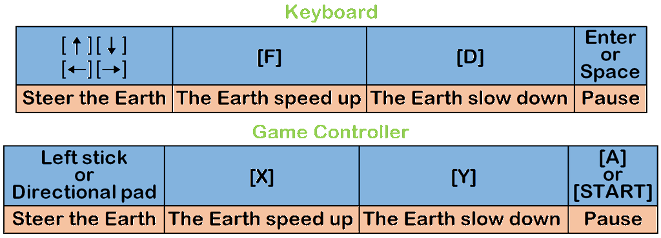
How To Operate On The Game Screen

I think using the left stick on a game controller allows you to control the Earth most freely and has the most fun.

Aim For The Goal Together With The Moon
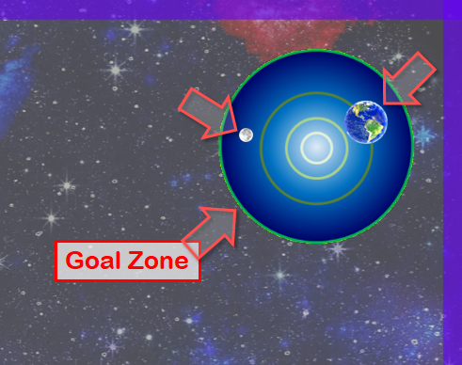
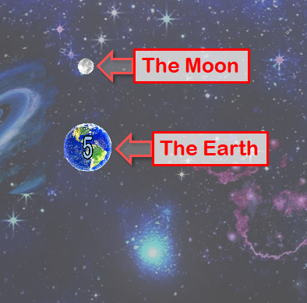
Steer the Earth, when both the Earth and the Moon are in the goal zone, the stage is cleared.

Depending on the stage, there will be other stars.
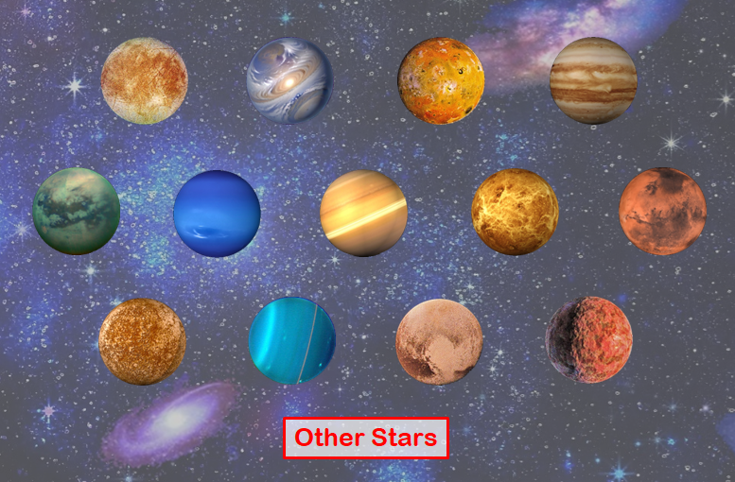

The Earth, the Moon, and other stars, have universal gravitation that attract other stars to them. You can't steer the Moon, but you can use the Earth's gravitational force to pull on the Moon.
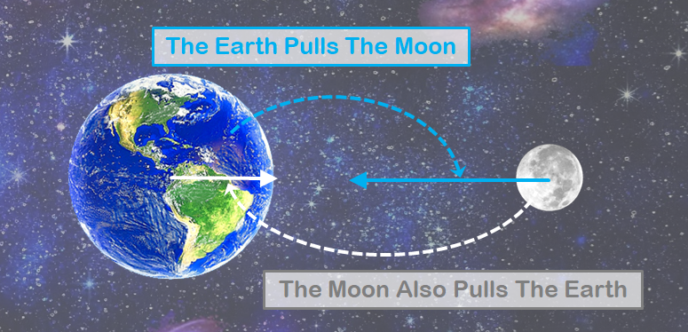
The larger the star, the stronger the gravitational force. (The bigger the star, the stronger the pull it has on other stars)
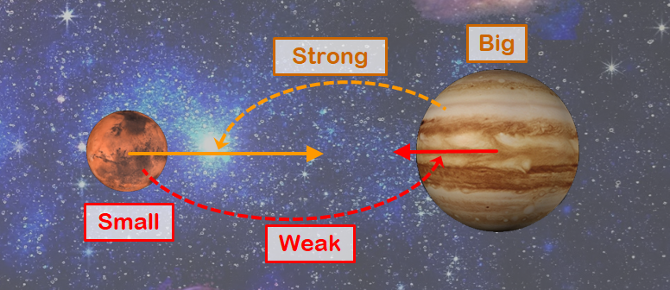

The strength of gravitation is inversely proportional to the square of the distance to the star. For example, if the distance is reduced by one third, The gravitational force will be nine times stronger. (As the distance gets closer, the gravitational force gets stronger rapidly.)
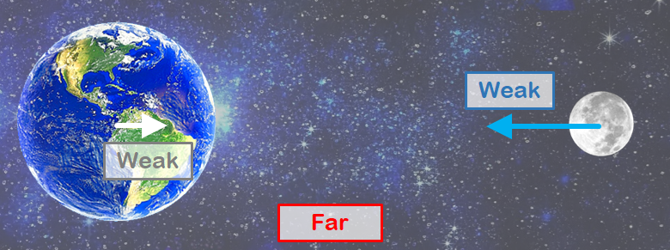
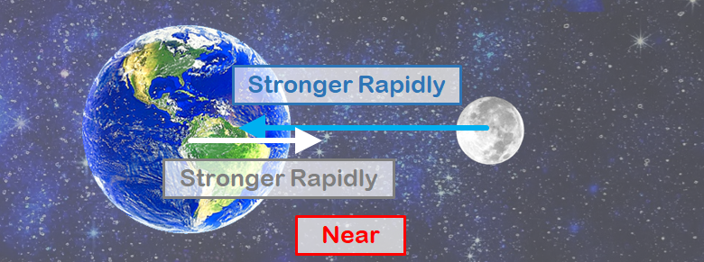

The Earth Damage
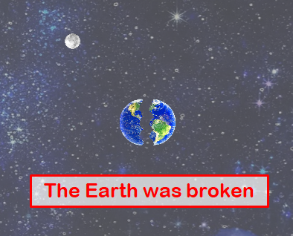
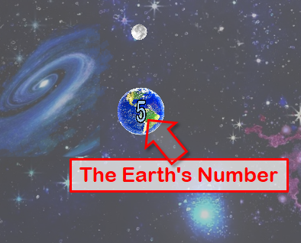
When the Earth collide with the Moon or other stars, The Earth will be damaged. When the Earth's number reaches 0 and the Earth is damaged, the Earth will break and you will fail to clear the stage.

Black Hole
Depending on the stage, there will be a black hole.
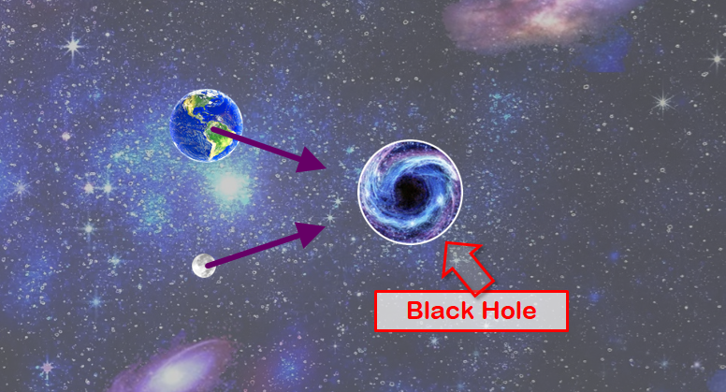
The gravitation of a black hole also pulls on the Earth and the Moon and other starts.
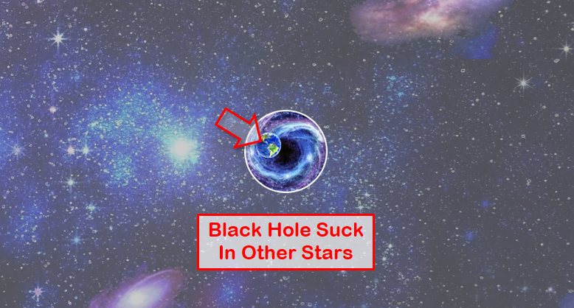
A black hole suck in the Earth and the Moon and other starts.
When a black hole sucks in the Earth or the Moon, you will fail to clear the stage.
White Hole
In this game's universe, there will be a white hole.
A white hole has a repulsive force that repels the Earth and the Moon and other starts.
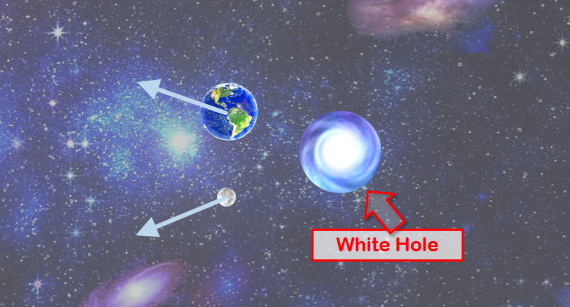
Other stars may emerge from the white hole at regular intervals.
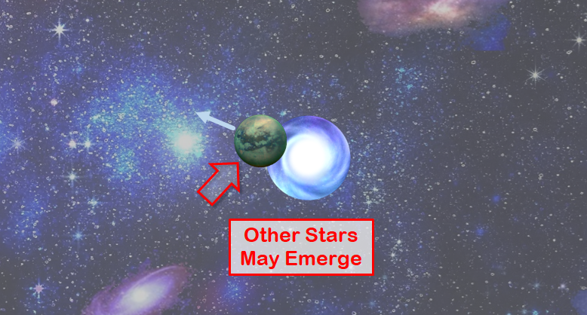
Wall
In this game's universe, walls exist.
The Earth and the Moon and other starts can't go through walls, but their gravitation reaches beyond the wall.
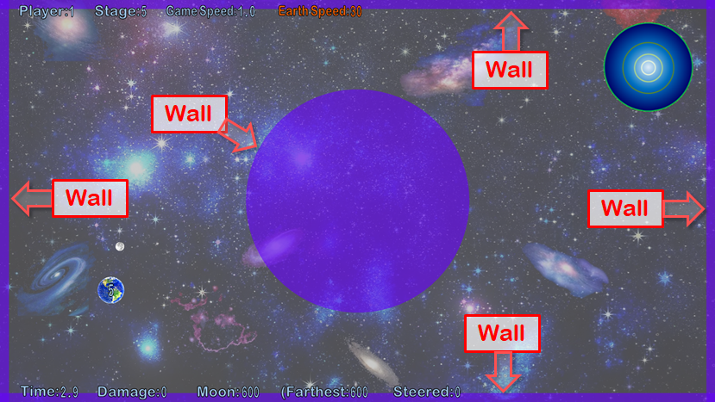

“MOVING WITH THE MOON: Mastering Universal Gravitation!”
Website

https://ssl-wada--system-com.cpi-common.jp/mwtm/index.html

