January 21, 2026
“MOVING WITH THE MOON: Mastering Universal Gravitation!”
Game For Windows PC
Now on sale at Steam and Microsoft Store

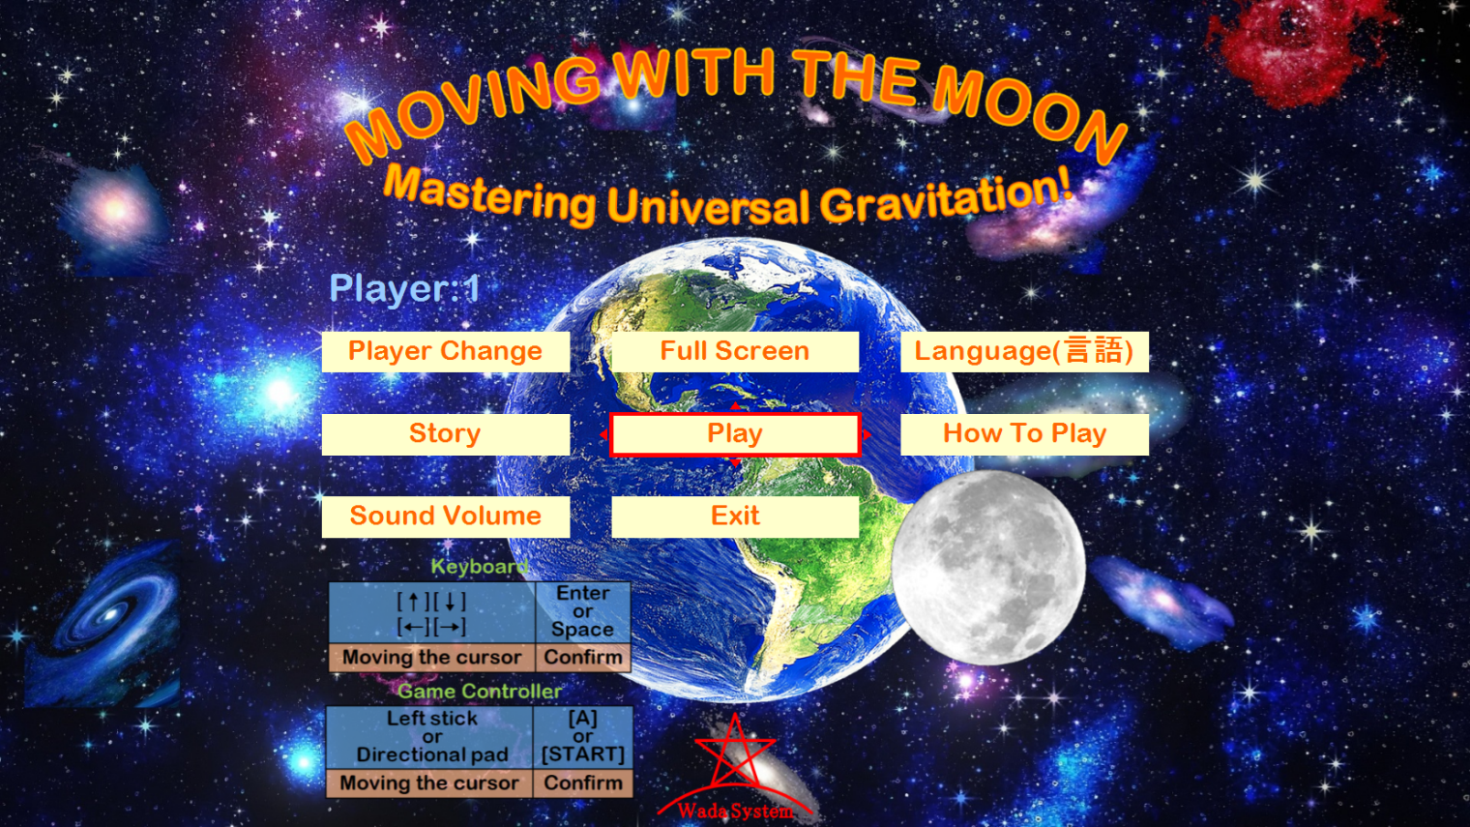
Wada System Limited released “MOVING WITH THE MOON: Mastering Universal Gravitation!” at Steam and Microsoft Store.

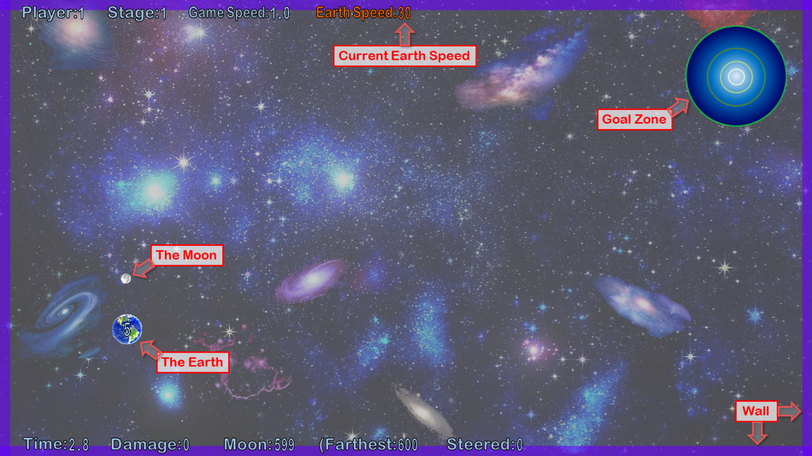
“MOVING WITH THE MOON: Mastering Universal Gravitation!” is a new type action game where you steer the Earth. It is simple rule and easy for anyone to play. And you can experience a simulated universal gravitation.
Simple Rule, Easy For Anyone To Play (Casual Game)
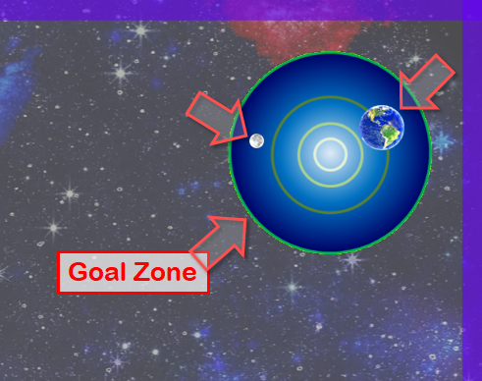
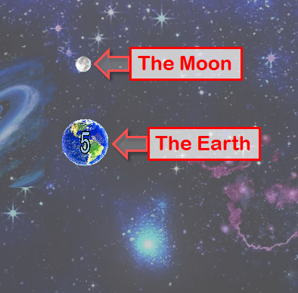
Steer the Earth, when both the Earth and the Moon are in the goal zone, the stage is cleared.

The Earth, the Moon, and other stars, have universal gravitation. You can't steer the Moon, but You can use the Earth's gravitational force to pull on the Moon.
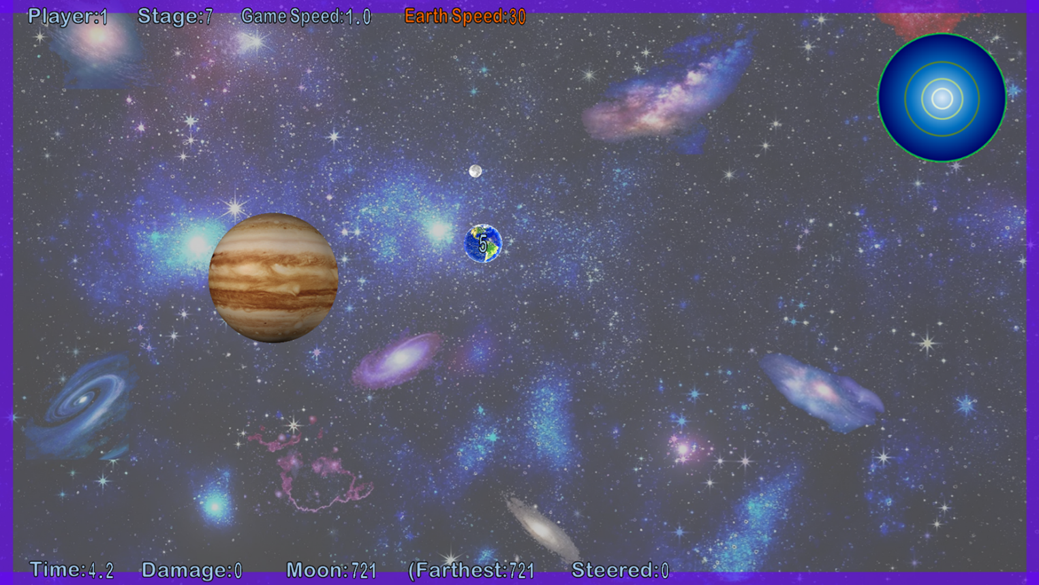
Depending on the stage, there will be other stars, black holes, white holes, walls. There will be also a large stage that cannot fit on one screen.

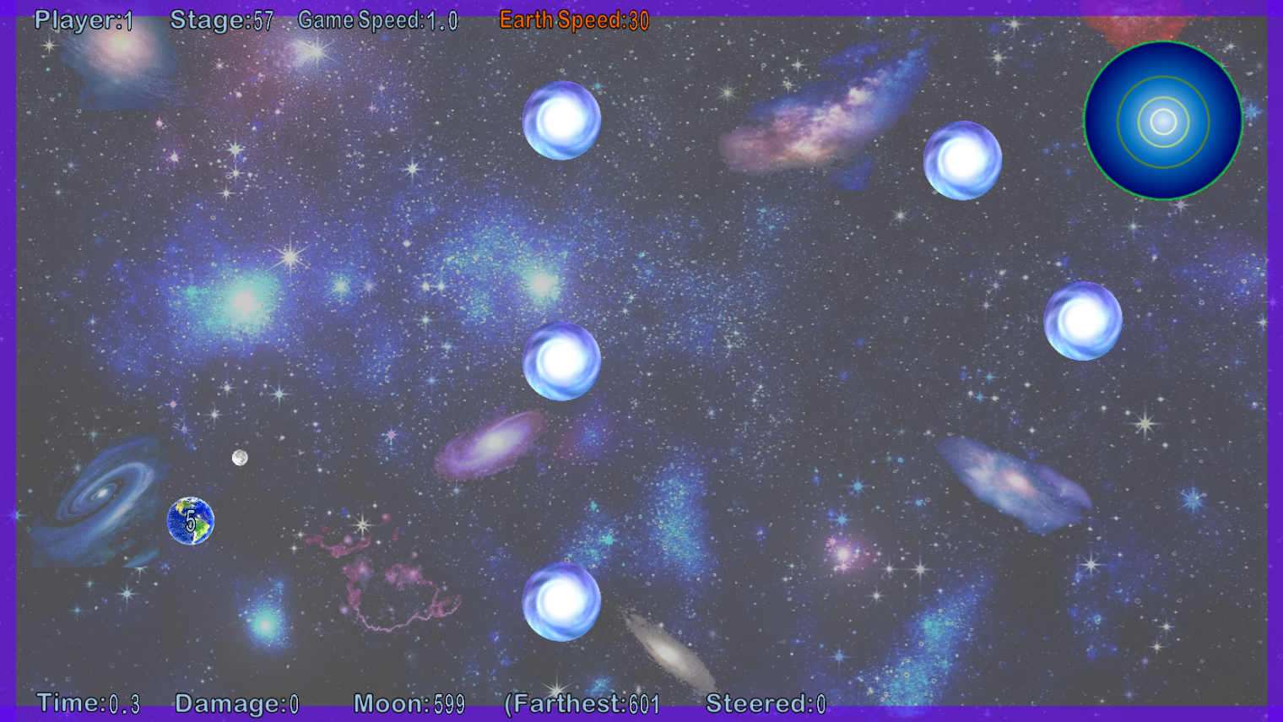
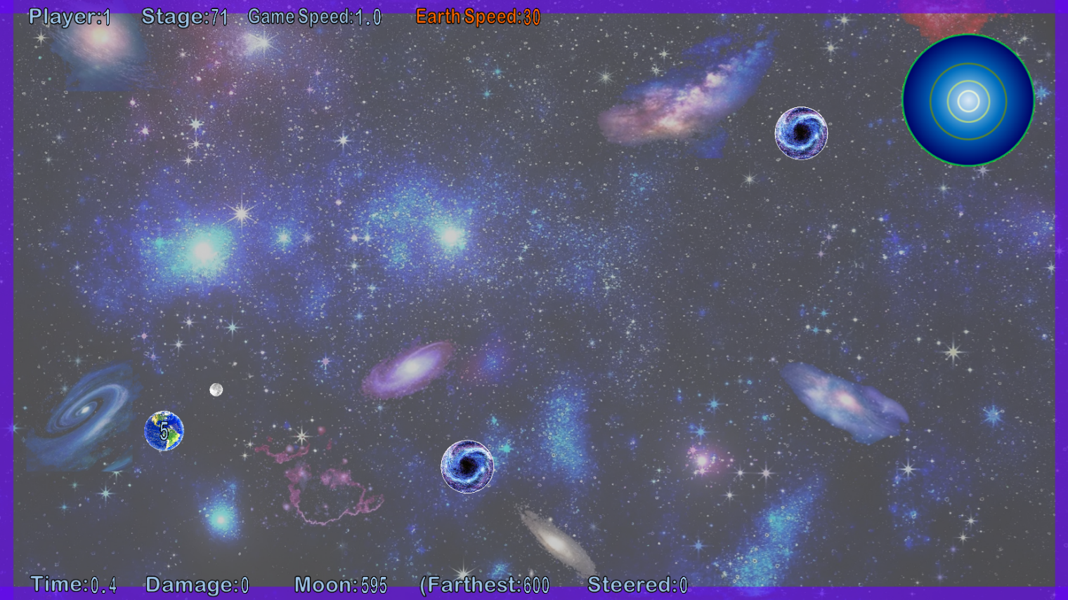
Not Too Hard, Easy To Enjoy
We try to keep the difficulty level from being too hard. We want to make sure that you enjoy the various stages. Many of the stages are short, and allowing you to quickly restart or try again.
You can choose the game speed you like. If you are not good at this type of game, you can make it easier by slowing down the game speed.
If it's too easy for you, we recommend that you try to speed up the game or aim to clear it with a good records.
You can play any stage you want at any time. (There are 100 stages in total.)

Enjoyable Even For Spectators
Because the rules and controls are very simple, it's enjoyable even for spectators.
It would be nice to post or livestream game play videos on social media (YouTube, Instagram, TikTok, or others) and enjoy with everyone. Posting or livestreaming gameplay videos of this game on social media is generally fine.

May Help Advance Science
This game may be a fun way to get people interested in science. We would be happy if we could contribute to the development of science in this world.
It is generally fine to exhibit this game in space or science museums, etc. It is generally fine to let everyone to play freely in those facilities.

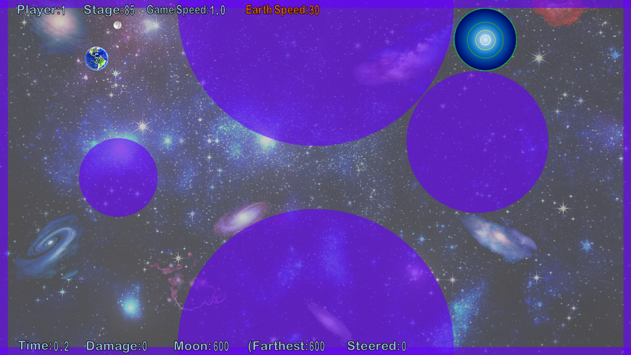
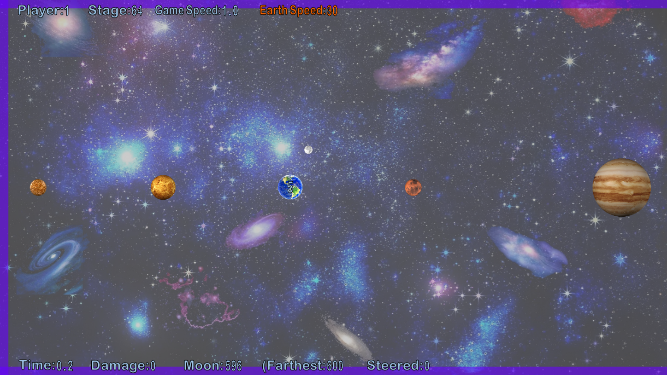
Introduction Video(YouTube): https://youtu.be/SuD6AKYq5VE
“MOVING WITH THE MOON: Mastering Universal Gravitation!”
System Requirements (You can play this game even on a computer that isn't very powerful.)
Device: PC
OS: Windows 10, 11
Disk space: 120MB
Genre: A new type action game where you steer the Earth
Operation method: A keyboard or a XInput game controller
Supported languages: English, Japanese
Price: $10, 8.5 Euros or equivalent
Release date: January 21, 2026
Website https://ssl-wada--system-com.cpi-common.jp/mwtm/index.html
E-mail inquiry@wada-system.com

Steam https://store.steampowered.com/app/4272960
Microsoft Store https://apps.microsoft.com/store/detail/9NHD9VFK32N7
(A trial version is available on both stores.)

Wada System Limited
Website https://ssl-wada--system-com.cpi-common.jp/index.html
4-25-30, Kamiaoki-nishi, Kawaguchi City, Saitama Prefecture 333-0845, Japan

