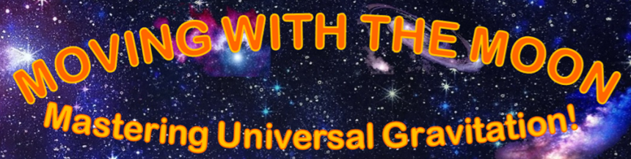
Story

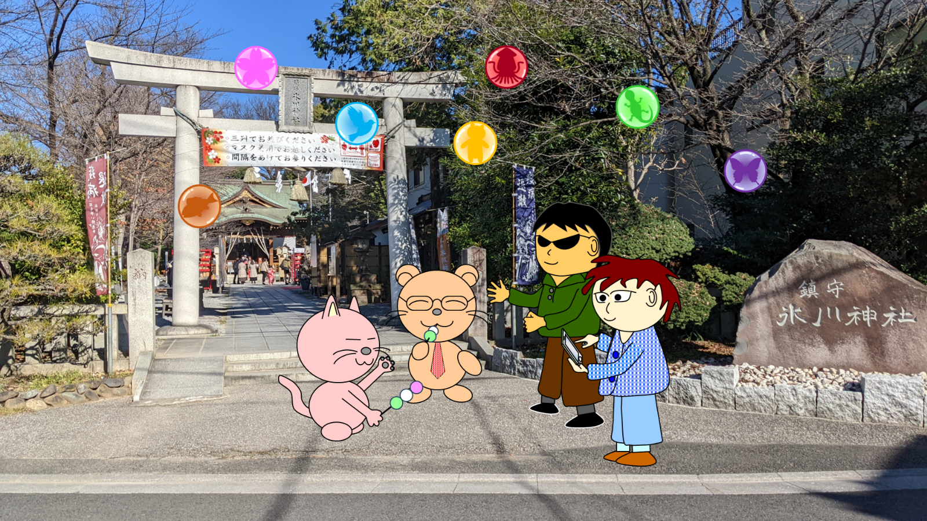

Sote

Fluffy fluffy, It's almost full moon party season in this area. The Moon orbits the Earth in an elliptical orbit circulatively. Because the moon is now closer to the Earth, The moon looks big.


Sakinobu

Meou meou, however, it's been too hot lately. This means we can't even enjoy the full moon party. Even though we are actively working on measures against global warming...


Koashi

Hmm hmm, It seems that the Sun is reaching the end of its life and is getting bigger and bigger. The earth revolves around the Sun circulatively. The Earth will eventually become too hot for living things to survive.


Soataroa

Yo yo, well, approximately 10 billion years have passed since the Sun was born. on Earth, life first appeared 9 billion years ago, humans evolved from monkeys appeared 5 billion years ago, now there are intelligent creatures that have evolved from various animals. But everyone's fate will come to an end.

Sakinobu

What!? Come on!

Soataroa

It would be different if the Earth could move somewhere else...

Sote

Umm, that would be impossible even with today's technology...


Circulation Fairy(Yellow)

Circular circular, we can do it.

Sote

Oh, Circulation Fairies. Really?


Circulation Fairy(Green)

We cannot directly move the matter of this world. But, because we are the fairies of the Earth, we can move the Earth.


Circulation Fairy(Blue)

However, we cannot move the Earth in the direction we want by our own will. You guys need to steer.

Soataroa

I see. In that case, we will be able to move the Earth and move somewhere else.


Circulation Fairy(Brown)

Incidentally, the only thing we can move is the Earth. we can't move the Moon.

Sote

Er, I guess it's fine without the Moon.

Sakinobu

What!? If there's no moon, we can't have a full moon party!

Soataroa

We can still party even if there's no Moon.

Sakinobu

But, no moon means less reason to party. And partying while watching the beautiful full moon is fun. That's what living things are like. It's because of these things that we can live a rich life.

Koashi

Well, The Earth rotates once a day. The gravitation of the Moon seems allows the Earth to rotate at a steady, gentle speed circulatively. And, without the Moon, the climate would be unstable.

Sote

Ah, without the moon, it seems like everyone's days won't go circulatively as smoothly as they used to. It's not going to be a kind world anymore.


Circulation Fairy(Purple)

Well, all matter in this world has universal gravitation. The Moon and the Earth are also pulled to each other by gravitation. Therefore, you can also move the Moon by using the Earth's gravitation to pull on it.

Soataroa

I understand. Then let's move with the Moon.


Circulation Fairy(Red)

The universe is vast. But, if we travel while frequently warping through warp zones, we'll find a good place sometime.


Circulation Fairy(Pink)

By the way, because we won't get sunlight during the travel, It would be best to enter the next warp zone as quickly as possible.

Sakinobu

There are other stars in the universe. Isn't there a danger? For example, the Moon may collide with the Earth...

Circulation Fairy(Yellow)

Well, if the Moon or other stars is about to hit the Earth, we can put up a barrier. But it's impossible to do it that many times. And, if the Earth or Moon were to be sucked into a black hole, that would be all over.

Circulation Fairy(Green)

Incidentally, whether the Moon is nearby or not has a big impact on everyone's lives. So, it would be best to keep the moon as close as possible.

Circulation Fairy(Blue)

To move the Earth in the direction you want, you need to use the Earth's energy. So, The distance to steer the Earth should be as short as possible.

Sote

Hmm, I understand. I wonder if we can successfully travel through space.

“MOVING WITH THE MOON: Mastering Universal Gravitation!”
Website

https://ssl-wada--system-com.cpi-common.jp/mwtm/index.html

